Name: HARINI A

Reg No: 192011344

CSA0734- Computer Networks for Server Management

Experiment: 02

Configuration of Topologies using Packet Tracer (ring)

AIM:

Configuration of Topologies ring using Packet Tracer.

REQUIREMENTS:

* End device - They are the devices through which we can pass message from one device to another and they are interconnected.
* Switch/Hub - Interface Between two devices.
* Cable - Used to connect two devices.

PROCEDURE:

STEP 1: Click on end devices, select generic Pc’s drag and drop it on thewindow. Click on SWITCH drag and drop it on the window.STEP 2: Select the straight through cable and connect all end device to switch. Assign the IP address for all end devices. (Double click the end device Select → desktop → IP configuration static)STEP 3: Now set the IP address to Host A (192.168.1.1) in static mode. Similarly set IP address for Host B (192.168.1.2) and Host C (192.168.1.3)STEP 5: To view the IP address, give ipconfig command in command prompt. Using ping command, we can establish communication between two host devices.STEP 6: Now display the packet transmission in simulation mode.

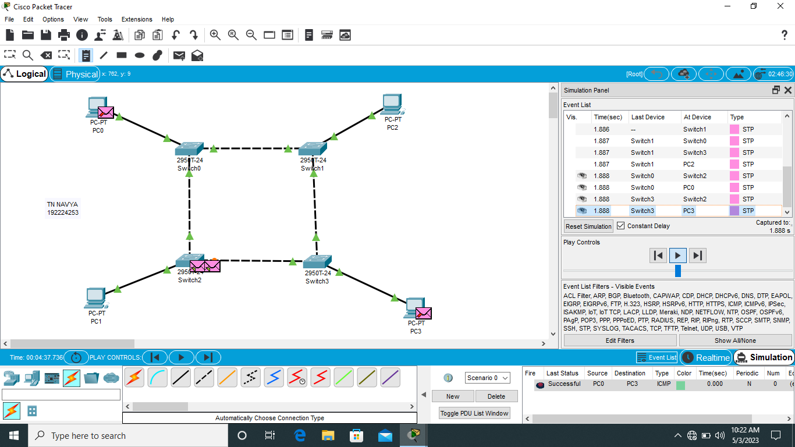

Result:

Configuration of Topologies using Packet Tracer communication star, mesh, tree is verified successful.